Press release

congatec heat pipe cooling solution for extreme environmental conditions

COMs just got even cooler

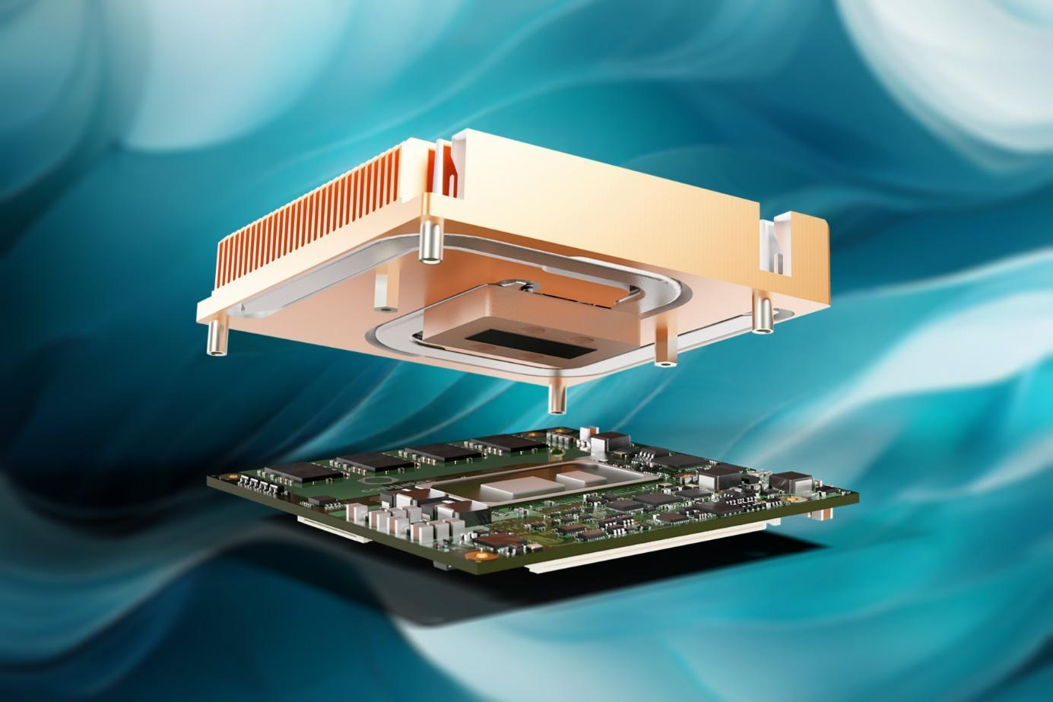

Deggendorf, Germany, March 11, 2025 * * * congatec – a leading provider of embedded and edge computing technology – premiered its heat pipe cooling solution for extreme environmental conditions at embedded world 2025. The new cooling solution uses acetone as a working fluid in the heat pipes instead of water. This prevents the thermal transfer medium from freezing at extreme sub-zero temperatures and prevents damage to the cooling solution, the module, and the entire system design. The new cooling solution is also insensitive to mechanical stresses such as shock and vibration.

With these features, the acetone-based cooling solution extends the application possibilities of Computer-on-Module (COMs) to use cases involving extreme climatic and mechanical conditions, such as arctic temperatures. It enables the use of COMs in systems that previously had to rely on more elaborate, complex and cost-intensive COTS-based slot or full-custom system designs to achieve the required reliability, thus reducing costs and safeguarding performance in challenging system applications. These properties make it the ideal choice for all COM-based designs that must operate reliably within a temperature range of -40 °C to +85 °C.

Jürgen Jungbauer, Senior Product Line Manager at congatec, explains: “Our new acetone-based cooling solution extends module-based designs to include applications under extreme operating conditions that could not previously be achieved with conventional cooling solutions. Using our application-ready COMs instead of expensive slot or special solutions allows developers to optimize time-to-market while reducing development effort and the overall costs of their applications.”

Applications for the new heat pipe cooling system include autonomous and conventional vehicles that are exposed to extreme conditions, such as logistics vehicles in ports, airports, and cold stores. The new solution is equally effective in rail and aviation systems, and any other scenario where extreme temperatures and mechanical stresses could affect system reliability.

When paired with the COMs Type6 conga-TC675 or the ultra-rugged conga-TC675r, the acetone-based heat pipe cooling solution is particularly effective. It also provides an ideal cooling solution for COMs in the form factors COM-HPC Mini and Client as well as COM-HPC Server for robust edge servers. The new cooling solution will also be available as a heat pipe adapter and other configurations on request.

This latest development reaffirms congatec's reputation for developing solutions that deliver efficient heat dissipation for effective cooling of intensive hotspots. The company's holistic approach to developing high-performance COMs ecosystems embraces suitable cooling solutions, carrier boards and comprehensive services, significantly simplifying and accelerating application development.

Concludes Jürgen Jungbauer: “We have always placed the greatest value on high-performance cooling for reliable computing. Our acetone-based cooling solution once again demonstrates our technological leadership in high-performance Computer-on-Module ecosystems.”

For more information on congatec’s cooling solutions please visit: https://www.congatec.com/en/technologies/cooling-solutions/

* * *

About congatec
congatec is a leading global provider of high-performance hardware and software building blocks for embedded and edge computing solutions based on Computer-on-Modules (COMs). These advanced computer modules drive systems and devices across industries such as industrial automation, medical technology, robotics, telecommunications, and more. congatec's high-performance aReady. ecosystems simplify and accelerate the solution development, from COM to cloud. This application-ready approach combines COMs with services and customizable technologies that enable cutting-edge advancements in system consolidation, IoT, security, and artificial intelligence. Supported by its majority shareholder, DBAG Fund VIII – a German mid-market fund focused on driving growth for industrial enterprises – congatec has the financial backing and M&A expertise to capitalize on expanding market opportunities. For more information, visit www.congatec.com or follow us on LinkedIn and YouTube.

Reader enquiries:
congatec
Phone: +49-991-2700-0
info@congatec.com
www.congatec.com

Press contact congatec:
congatec
Christof Wilde
Phone: +49-991-2700-2822
christof.wilde@congatec.com

Press contact agency:
Publitek GmbH
Julia Wolff
+49 (0)4181 968098-18
julia.wolff@publitek.com
Bremer Straße 6
21244 Buchholz

Please send print publications to:
Publitek GmbH
Joke Klein
Bremer Straße 6
21244 Buchholz

