Press release

AMI and congatec Celebrate 20 Years of Successful Partnership

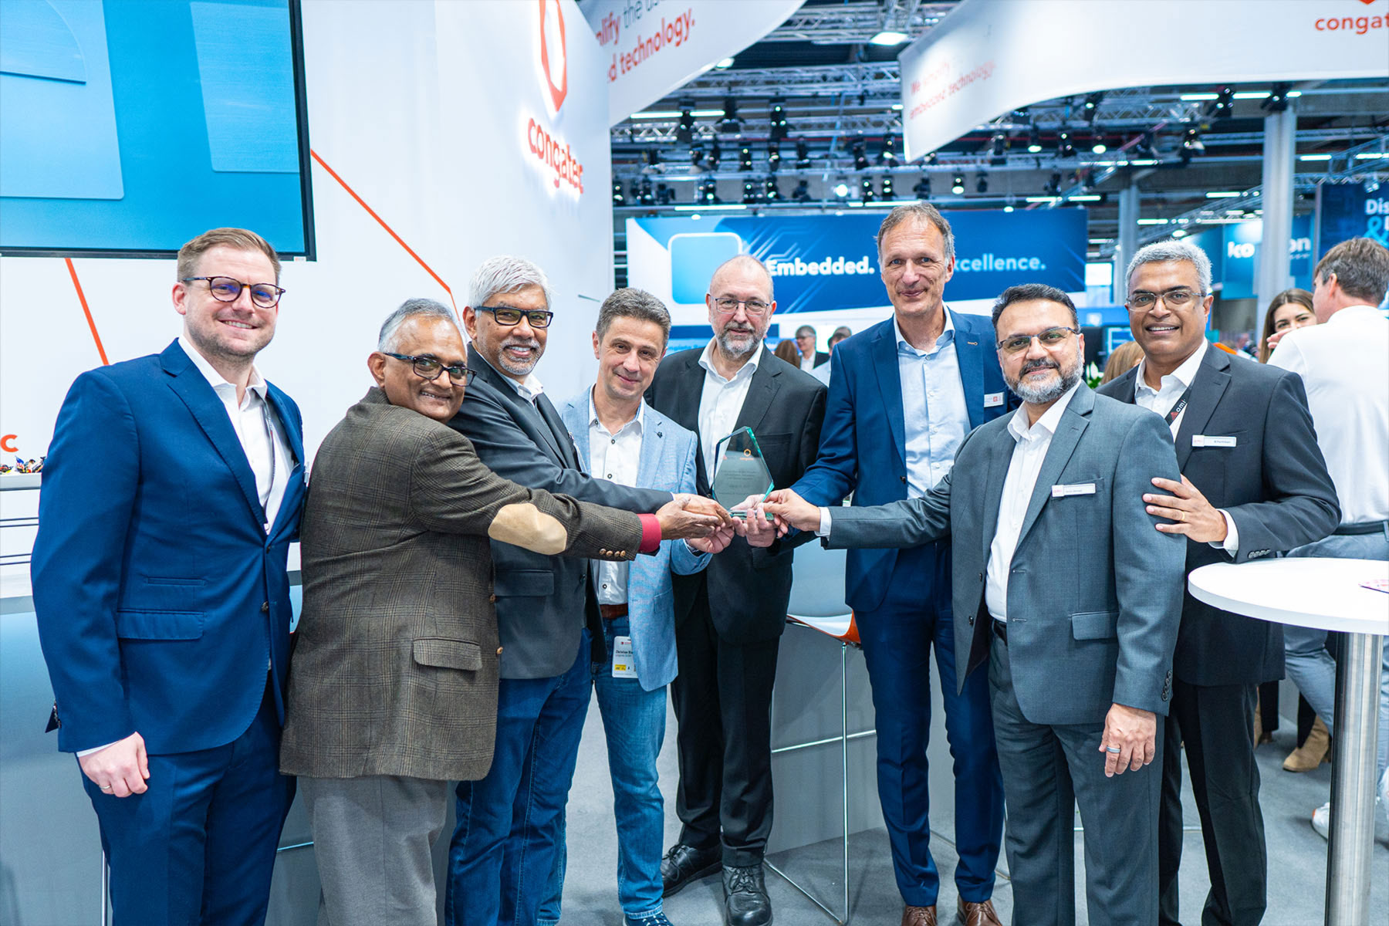

Atlanta, USA / Deggendorf, Germany, March 11, 2025 * * * AMI®, the global leader in Dynamic Firmware for worldwide computing, and congatec, a leading provider of embedded and edge computing technology, today announced the celebration of their 20-year business partnership.

Since 2005, AMI and congatec have worked closely together to deliver innovative embedded computing solutions to customers worldwide. This long-standing collaboration has driven both companies to develop advanced technologies and provide exceptional support to their shared customer base - even for the most sophisticated technical challenges for embedded systems.

"We are thrilled to celebrate 20 years of successful partnership with congatec," said Sanjoy Maity, CEO of AMI. "Our companies have collaborated extensively to push the boundaries of embedded computing over the past two decades - so it is very fitting that we mark this occasion here at the opening of Embedded World 2025.”

"From the very beginning, AMI has been a trusted and invaluable partner in congatec's journey toward market excellence. Their deep expertise in BIOS and firmware solutions has been instrumental in enabling us to deliver the highest standards of performance, reliability, and security with our COMs. We look forward to continuing our collaboration for decades to come, driving innovation in embedded and edge computing," said Dr. Dominik Ressing, CEO of congatec.

Imran Ahmad, AMI Chief Sales Officer, added that “As a party to the signing of our original agreement with congatec, I have witnessed what our two companies have achieved together with great pride. This 20-year milestone between AMI and congatec is a testament to our shared commitment to innovation, quality, and customer satisfaction. We look forward to many more years of fruitful collaboration together as we continue to drive progress in the embedded computing industry."

"AMI has been an extremely reliable partner for congatec for the past 20 years," said Christian Riesinger, Founding Member and Senior FAE of congatec. "As our very first technology partner, AMI has been with us every step of the way. In fact, we signed our original agreement with AMI while congatec was still a start-up! But AMI treated us as a valued partner from the beginning, quickly earning our trust through their expertise and high-quality implementation. We have always been satisfied with the high level of technical support AMI has provided. Together, we have empowered innovation with secure, high-performance embedded building blocks, so our customers can promptly seize opportunities and establish themselves as industry frontrunners.”

The 20-year partnership between AMI and congatec has resulted in the development of numerous successful embedded computing products and solutions. By combining AMI's expertise in UEFI firmware and remote management technologies with congatec's leadership in standardized and customized embedded computer boards and modules, the two companies continue to deliver comprehensive, high-performance embedded computing platforms to our customers.

Looking to the future, AMI and congatec remain committed to strengthening their partnership and delivering even more innovative embedded solutions to meet the evolving needs of their global customer base..
* * *

About AMI

AMI is Firmware Reimagined for modern computing. As a global leader in Dynamic Firmware for security, orchestration, and manageability solutions, AMI enables the world’s compute platforms from on-premises to the cloud to the edge. AMI’s industry-leading foundational technology and unwavering customer support have generated lasting partnerships and spurred innovation for some of the most prominent brands in the high-tech industry.

About congatec
congatec is a leading global provider of high-performance hardware and software building blocks for embedded and edge computing solutions based on Computer-on-Modules (COMs). These advanced computer modules drive systems and devices across industries such as industrial automation, medical technology, robotics, telecommunications, and more. congatec's high-performance aReady. ecosystems simplify and accelerate the solution development, from COM to cloud. This application-ready approach combines COMs with services and customizable technologies that enable cutting-edge advancements in system consolidation, IoT, security, and artificial intelligence. Supported by its majority shareholder, DBAG Fund VIII – a German mid-market fund focused on driving growth for industrial enterprises – congatec has the financial backing and M&A expertise to capitalize on expanding market opportunities. For more information, visit www.congatec.com or follow us on LinkedIn and YouTube.

Reader enquiries:
congatec
Phone: +49-991-2700-0
info@congatec.com
www.congatec.com

Press contact congatec:
congatec
Christof Wilde
Phone: +49-991-2700-2822
christof.wilde@congatec.com

Press contact agency:
Publitek GmbH
Julia Wolff
+49 (0)4181 968098-18
julia.wolff@publitek.com
Bremer Straße 6
21244 Buchholz

Please send print publications to:
Publitek GmbH
Joke Klein
Bremer Straße 6
21244 Buchholz

