**Press 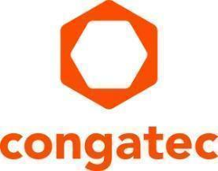release**

From start-up to world leader in embedded computing technology

**congatec celebrates its 20th anniversary**

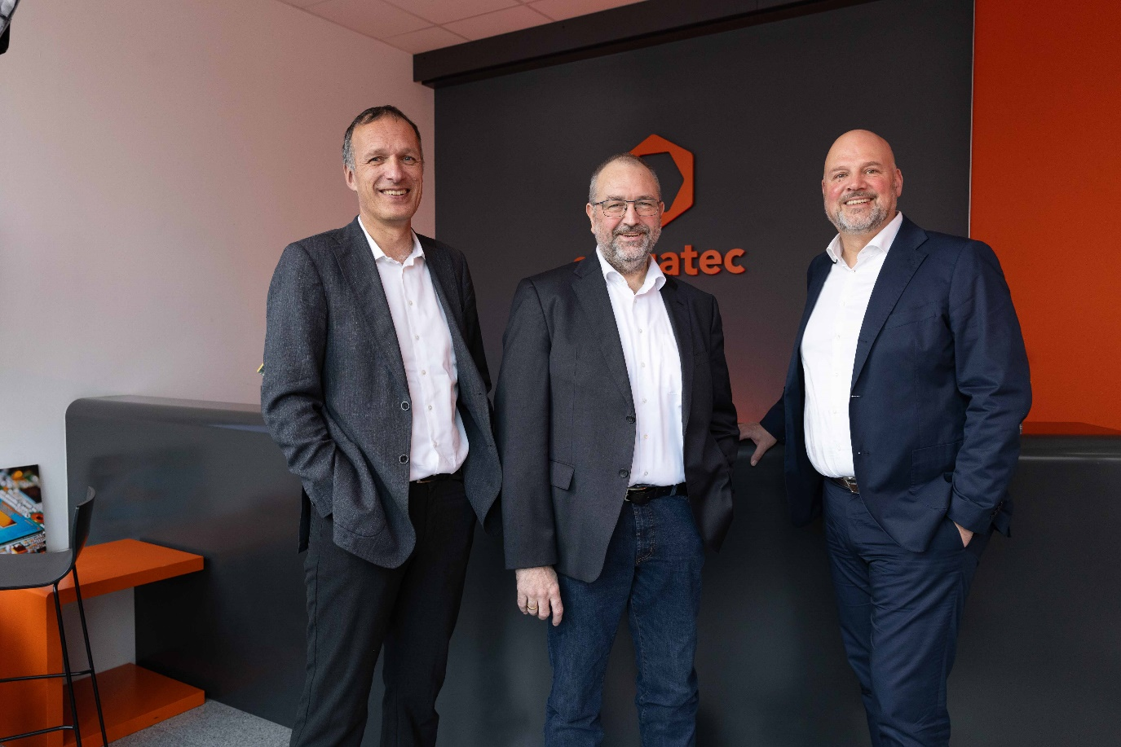

*Celebrating 20 successful years: Dr. Dominik Ressing (CEO), Konrad Garhammer (COO & CTO), and Daniel Jürgens (CFO) (from left to right)*

**Deggendorf, Germany, December 12, 2024** * * * congatec—a leading provider of embedded and edge computing technology—celebrates its 20th anniversary today. Over the past 20 years, congatec has grown from an innovative start-up to a global market leader for standardized Computer-on-Modules (COMs). Consistently pursuing its vision, congatec aims to provide sustainable, innovative, and high-performance embedded computing technology from COM to cloud, shortening innovation cycles and time-to-market for its customers. This application-ready approach combines COMs with services and advanced customizable

technologies for system consolidation, IoT, security, and artificial intelligence.

Dominik Ressing, CEO of congatec, highlights the company’s innovative spirit: “Since the company was founded, congatec’s goal has been to simplify embedded technology and help customers maximize the value of their solutions. We are continuously developing our Computer-on-Modules, software, and services, always with an eye on new ideas.”

**Becoming a global player**

In December 2004, 13 employees founded congatec in Deggendorf, Germany. 20 years later, congatec has become a leading innovator in the embedded market. The manufacturer of standardized Computer-on-Modules and secure, application-ready high-performance hardware and software building blocks achieved annual revenues of 192 million US dollars in 2023. With over 25 global sales partners and offices in EMEA, APAC, and the USA, congatec has delivered over 10 million solutions for customers across various industries. Daniel Jürgens, CFO at congatec, emphasizes the company’s strength: “The passion, expertise, trust, and teamwork of our employees are our greatest asset and have established us as one of the world’s leading Computer-on-Module providers. Our strong corporate culture is the foundation of this success and continues to drive innovation.”

Beyond its strong corporate culture and dedicated employees, congatec’s success also stems from the industry’s open embedded computing standards that the company has actively helped shape since 2004. Initially, congatec was involved under the banner of the PCI Computer Manufacturers Group (PICMG), and since 2012, the company has been a founding member of the Standardization Group for Embedded Technologies (SGET).

As congatec COO & CTO Konrad Garhammer underlines: “Computer-on-Modules are in our DNA. Since our foundation, we have actively promoted open COM standards, accessories, and services to bring the best COM ecosystems to market and generate sustainable benefits for our customers.”

A first standardization milestone was the publication of the PICMG COM Express specification in May 2005, in which congatec played a pivotal role. The company quickly followed this by introducing its first COM Express module in 2006. Further achievements included implementing the Qseven specification in 2008 and launching the first SMARC module in 2016 as part of the SGET. The current success of the COM-HPC high-speed embedded standard particularly validates the company’s commitment to open standards. Christian Eder, a founding member of congatec and chair of the PICMG COM-HPC Working Group, recently reported on the launch of the new Carrier Design Guide.

**More efficiency and faster time-to-market**

With the aReady. strategy implemented in 2023, congatec has provided its COM technology with a significant innovation boost by offering customers modular hardware and software building blocks. This approach simplifies the development of highly scalable and flexible solutions from COM to cloud. Customers can now access a comprehensive package including hardware, hypervisor, cybersecurity, operating systems, and functional software, enabling even faster time-to-market while allowing them to consistently focus on their core competencies. congatec provides all operating systems and software components ready-to-use and fully licensed, facilitating a faster and more straightforward entry into embedded computing. Konrad Garhammer adds: “Every employee at congatec is dedicated to leveraging their expertise in developing new hardware and software building blocks that help us and our customers achieve our shared goals.”

The innovations of the past 20 years provide a perfect foundation for working on future technologies and shaping tomorrow’s world. congatec represents embedded technology that is user-friendly, easily scalable, sustainable, and interoperable – all supported by a large community.

“In an era of rapid technological progress, we are committed to empowering our customers to swiftly adapt to breakthrough technologies and take a pioneering role in their industries. We will continue to simplify the use of embedded technology, regardless of what the future may bring. Together, we are creating a world where technology drives innovation, propels progress, and transforms industries,” says Dominik Ressing, looking optimistically to the future.

congatec’s complete history can be found at: [20years.congatec.com](https://20years.congatec.com)

* * *

**About congatec**

congatec is a leading global provider of high-performance hardware and software building blocks for embedded and edge computing solutions based on Computer-on-Modules (COMs). These advanced computer modules drive systems and devices across industries such as industrial automation, medical technology, robotics, telecommunications, and more. congatec's high-performance aReady. ecosystems simplify and accelerate the solution development, from COM to cloud. This application-ready approach combines COMs with services and customizable technologies that enable cutting-edge advancements in system consolidation, IoT, security, and artificial intelligence. Supported by its majority shareholder, DBAG Fund VIII – a German mid-market fund focused on driving growth for industrial enterprises – congatec has the financial backing and M&A expertise to capitalize on expanding market opportunities. For more information, visit [www.congatec.com](http://www.congatec.com/) or follow us on LinkedIn and YouTube.

Text and photograph available at: <https://www.congatec.com/en/congatec/press-releases.html>

**Reader enquiries:**

congatec

Phone: +49-991-2700-0

[info@congatec.com](mailto:info@congatec.com)

[www.congatec.com](http://www.congatec.com/)

**Press contact congatec:**

congatec

Christof Wilde

Phone: +49-991-2700-2822

[christof.wilde@congatec.com](mailto:christof.wilde@congatec.com)

**Press contact agency**:

Publitek GmbH

Julia Wolff

+49 (0)4181 968098-18

[julia.wolff@publitek.com](mailto:julia.wolff@publitek.com)

Bremer Straße 6

21244 Buchholz

Germany

**Please send print publications to**:

Publitek GmbH

Diana Penzien

Bremer Straße 6

21244 Buchholz

Germany