**Press release**

congatec presents new COM Express Compact modules with AMD Ryzen Embedded 8000 Series for high-performance AI applications at the edge

**Compact module delivers 39 TOPS AI performance**

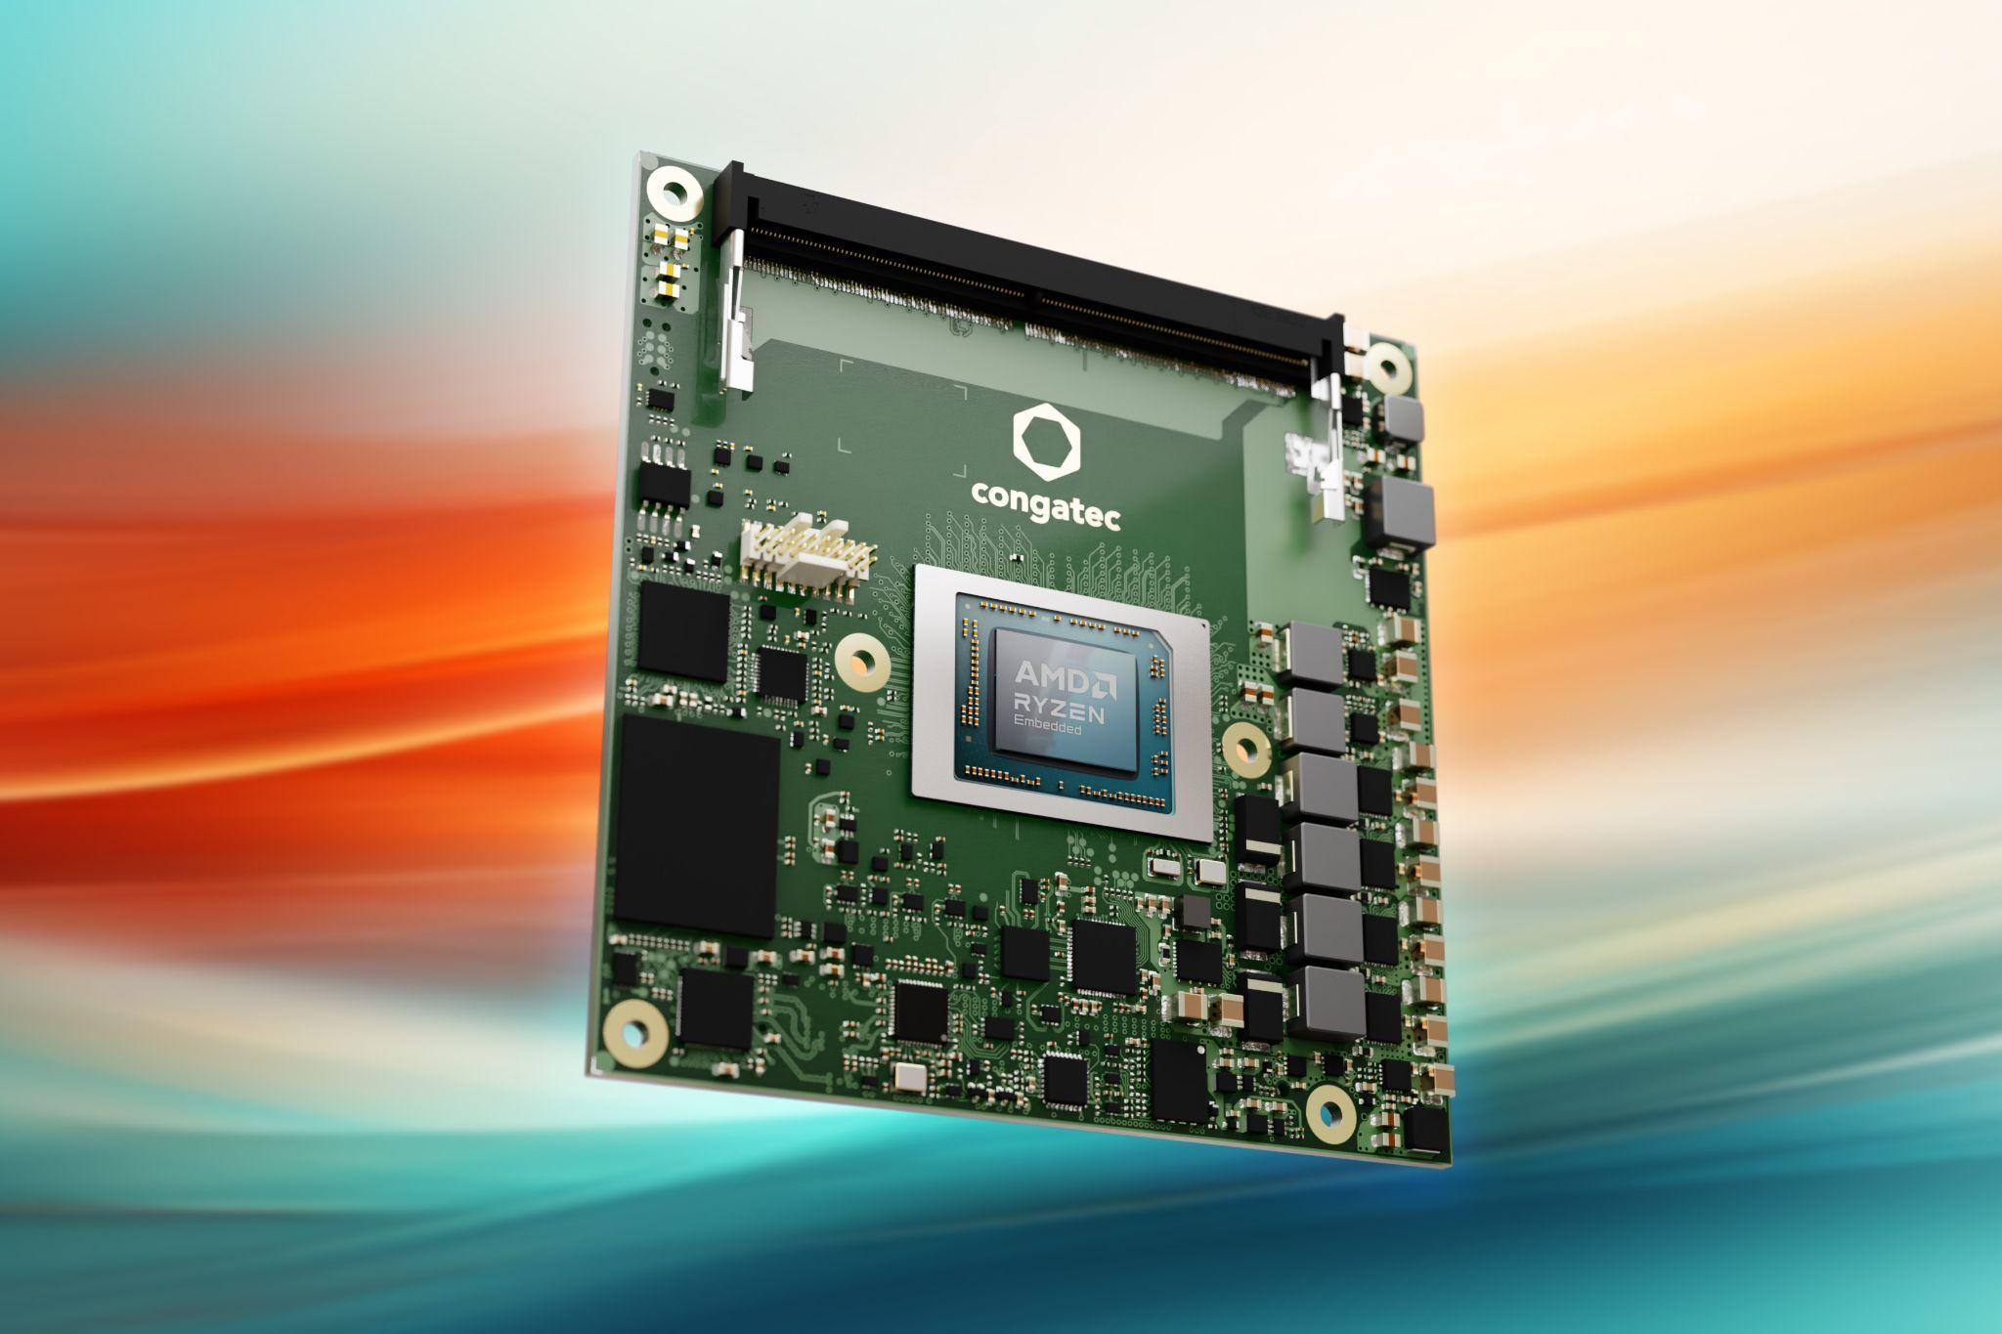

**San Diego, CA, September 17, 2024** * * * congatec - a leading provider of embedded and edge computing technology – introduces new COM Express Compact Computer-on-Modules with AMD Ryzen Embedded 8000 Series processors. Based on the dedicated computing cores of the new Ryzen processors featuring up to eight ‘Zen 4’ cores, innovative XDNA™ NPU, and powerful Radeon RDNA 3™ graphics, the new modules deliver impressive performance of up to 39 tera operations per second (TOPS) for AI inference.

This makes the new conga-TCR8 Type 6 modules particularly appealing for high-volume, price-sensitive applications requiring a combination of advanced AI, graphics, and computing power. OEMs in medical imaging, test & measurement, AI-supported POS/POI systems, and professional gaming can leverage these long-term available COM Express Compact modules to accelerate innovation while ensuring investment security. With a broad, scalable TDP range of 15 to 54 Watt, these modules are also ideal for upgrading existing designs. By simply replacing modules, companies can bring their products to the latest state of the art, significantly improving lifecycle, ROI, and sustainability.

“Our new AMD Ryzen Embedded 8000-based modules not only expand our range of high-performance edge AI platforms for innovative applications, but also offer developers easy access to system consolidation benefits in the aReady.COM variant. This new processor platform, featuring powerful CPU, GPU, and NPU cores, is perfectly suited for such consolidation. Customers and users benefit from cost, efficiency, and reliability advantages thanks to a configured hypervisor, pre-installed operating systems, accompanying IoT software for enhanced functionality, and flexible expansion options,” explains Martin Danzer, Director Product Management at congatec.

**The feature set in detail**

The new conga-TCR8 Computer-on-Modules from congatec are available with four different AMD Ryzen Embedded 8000 processors featuring six or eight ‘Zen 4’ cores. They support up to 128GB DDR5-5600 memory with error correction code (ECC) for data-intensive and data-critical applications. With the integrated AMD XDNA™ NPU (16 TOPS) and AMD Radeon RDNA™ 3 graphics, which can also be used as a GPGPU for AI tasks with up to 12 compute units, they deliver a combined computing power of up to 39 TOPS. They also support immersive graphics output on up to four displays with resolutions as high as 8k. For fast peripheral connectivity, they offer six PCIe Gen 4 (8 lanes) with PEG x8 Gen 4, three DisplayPort (DP) interfaces, one eDP or LVDS, four USB 3.2 Gen 2 ports, and four USB 2.0 ports. Audio signals are delivered via HAD, and mass storage can be integrated through two SATA 6 Gb/s ports or an optional NVMe SSD directly on the module. Classic embedded interfaces such as SPI, UART, I2C, and GPIO complete the feature set.

The new COM Express Compact modules are also available as application-ready aReady.COMs, with custom pre-installed and validated operating systems like ctrlX OS, Ubuntu and/or RT Linux, optional system consolidation via aReady.VT, and IoT connectivity via aReady.IOT. On request, the modules can be pre-installed with the customer’s application, allowing for simple plug-and-play integration into the finished system.

Moreover, congatec’s high-performance ecosystem and design-in services simplify the application development process. The service offering includes comprehensive board support packages, evaluation and production-ready application carrier boards, customized cooling solutions, extensive documentation and training, and high-speed signal integrity measurements.

The new conga-TCR8 COM Express Compact modules are available in the following variants:

| **Model** | **TDP** | **Cores** | **Threads** | **Base clock / Turbo** | **Compute Units** |
| --- | --- | --- | --- | --- | --- |
| AMD Ryzen™ Embedded 8845HS | 45 W (35-54 W) | 8 | 16 | 3.8 / 5.1 | 12 |
| AMD Ryzen™ Embedded 8840U | 28 W (15-30 W) | 8 | 16 | 3.3 / 5.1 | 12 |
| AMD Ryzen™ Embedded 8645HS | 45 W (35-54 W) | 6 | 12 | 4.3 / 5.0 | 8 |
| AMD Ryzen™ Embedded 8640U | 28 W (15-30 W) | 6 | 12 | 3.5 / 4.9 | 8 |

Further information about the new conga-TCR8 modules is available at: [conga-TCR8](https://www.congatec.com/en/products/com-express-type-6/conga-tcr8/)

For further information about the COM Express standard visit: <https://www.congatec.com/en/technologies/com-express/>

* * *

**About congatec**

congatec is a rapidly growing technology company focusing on embedded and edge computing products and services. The high-performance computer modules are used in a wide range of applications and devices in industrial automation, medical technology, robotics, telecommunications and many other verticals. Backed by controlling shareholder DBAG Fund VIII, a German midmarket fund focusing on growing industrial businesses, congatec has the financing and M&A experience to take advantage of these expanding market opportunities. congatec is the global market leader in the computer-on-modules segment with an excellent customer base from start-ups to international blue chip companies. More information is available on our website at [www.congatec.com](https://www.congatec.com/) or via [LinkedIn](https://www.linkedin.com/company/congatec/), [X (Twitter)](https://twitter.com/congatecAG) and [YouTube](https://www.youtube.com/user/congatecAE).

Text and photograph available at: <https://www.congatec.com/en/congatec/press-releases.html>

*AMD, the AMD logo, and other AMD marks are trademarks of AMD Corporation or its subsidiaries.*

**Reader Enquiries:**

congatec

Farhad Sharifi

Phone: 858-457-2600

[Farhad.Sharifi@congatec.com](mailto:Farhad.Sharifi@congatec.com)

[www.congatec.us](http://www.congatec.us)

**Press Contact:**

congatec

Janene Rae

Phone: 858-457-2600

[janene.rae@congatec.com](mailto:janene.rae@congatec.com)

www.congatec.us

**PR Agency:**

Publitek GmbH

Julia Wolff

+49 (0)4181 968098-18

[julia.wolff@publitek.com](mailto:julia.wolff@publitek.com)

Bremer Straße 6

21244 Buchholz

**Please send print publications to:**

Publitek GmbH

Diana Penzien

Bremer Straße 6

21244 Buchholz