
Press release

congatec spotlights aReady.COM Computer-on-Modules at embedded world North America

A new level of application readiness - for increased efficiency and reliability

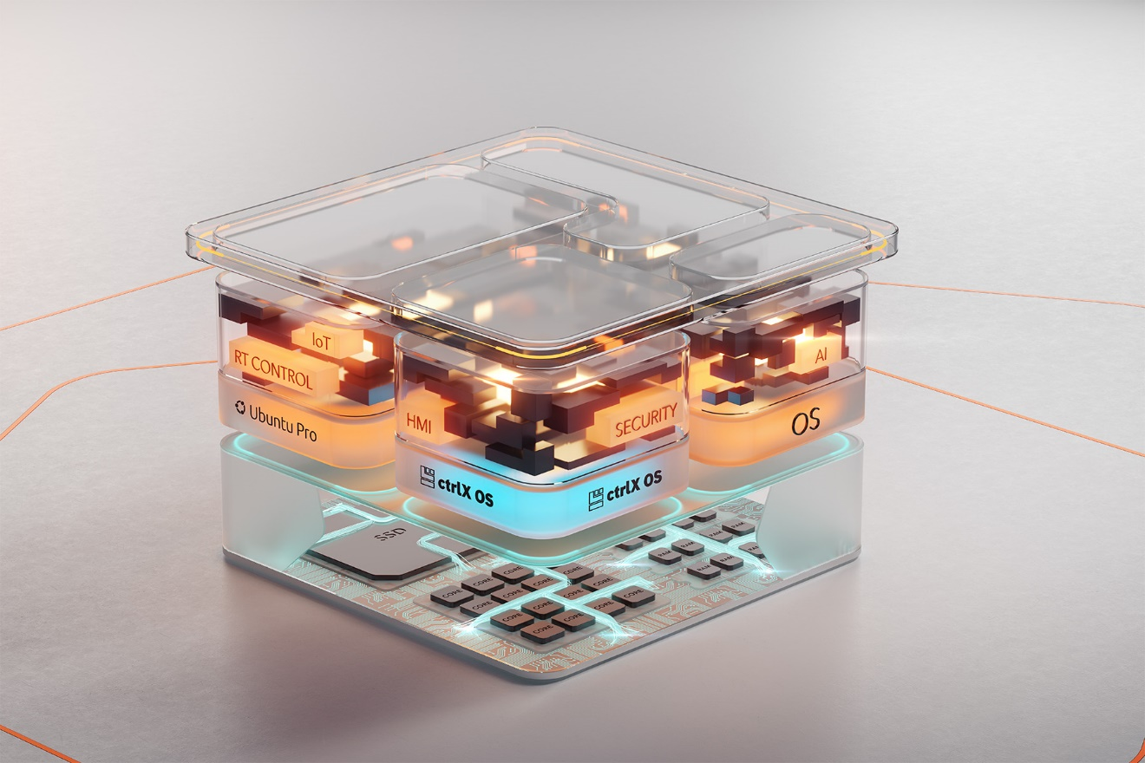

San Diego, CA, September 19, 2024 * * * congatec – a leading vendor of embedded and edge computing technology – will spotlight its extensive Computer-on-Modules portfolio in different aReady.COM configurations at embedded world NA (booth 2223). aReady.COM Computer-on-Modules have value-added software features that simplify their use in different application scenarios and define a new high-performance class of off-the-shelf available Computer-on-Modules for all standard form factors such as COM-HPC, COM Express and SMARC. The functionally validated aReady.COM configurations save software engineers time in validating and verifying basic software building blocks, enabling them to deploy their software solutions on target systems faster and more efficiently. The various aReady.COM configurations are available for all congatec Computer-on-Modules with integrated storage devices (NVMe) based on the 13th generation Intel Core (codenamed Raptor Lake), Intel Core Ultra, Intel Atom (codenamed Amston Lake) and AMD Ryzen 8000 processors.

"We are pleased to present our new aReady.COM solution platforms live at embedded world NA. With aReady.COM, congatec has created one of the highest levels of application readiness for commercially available Computer-on-Modules on the market. Modules ordered in aReady.COM configurations have a validated operating system, hypervisor and/or IoT software package pre-installed in specific configurations, so engineers can immediately boot the module to install their applications right out of the box," said Farhad Sharifi, General Manager, congatec Americas.

"The benefit of aReady.COM Computer-on-Modules is that application engineers don't need to validate the OS, hypervisor and/or IoT software packages to run smoothly on the different modules. This saves time and money in the product development process. In volume production, they reduce the bill of materials, streamline license, patch and update management, and all installation routines and functional testing are already done," says Dan Demers, Senior Director Business Development at congatec Americas.
The Computer-on-Modules based on the 13th generation Intel Core (codenamed Raptor Lake), Intel Atom (codenamed Amston Lake), and AMD Ryzen 8000 processors are available in several aReady.COM configurations that can be freely specified by the customer:
aReady.COM with OS
The first level of an aReady.COM is a pre-installed operating system tailored to the specific Computer-on-Modules. Engineers can choose from several Linux distributions (RT Linux, Ubuntu) as well as Bosch ctrlX OS and order dedicated OS images tailored to the dedicated COM & carrier setup.

aReady.VT
aReady.VT adds a partitioning of the hardware for system consolidation and interference-free task separation by the Hypervisor-on-Module. It features individually pre-configured virtual machines ready to host the required OS configurations. In addition, the virtual machines can be deployed with the required operating systems and optionally IoT software functions.

aReady.IOT
aReady.IOT offers building blocks for IoT functions such as data converters, system and device monitoring or a complete white label solution platform for OEMs to build digitization solutions, which only needs to be configured and parameterized to bring devices into the clouds and run a set of IoT applications. Another option is to install the IoT applications in virtual machines to accompany the OEM's core application.

The most sophisticated aReady.COM yet
Of course, a combination of all options is always possible. congatec’s aReady.VT and aReady.IOT offerings in combination with the ctrlX OS from the ecosystem partner Bosch Rexroth including access to the ctrlX Store represent the most sophisticated aReady.COM expansion stage. The ctrlX Store is a real app-treasure-cove in this context. It offers a wide portfolio including PLC and motion control applications as well as communication and engineering tools. Developers also have access to a variety of IoT and cloud applications, including basic functions such as firewalls and VPN clients. Key target markets for ctrlX OS in the embedded computing segment include automation, robotics, medical, energy/smart grids and in-vehicle applications.

More information about aReady.COM can be found at https://aready.com/
* * *

About congatec
congatec is a rapidly growing technology company focusing on embedded and edge computing products and services. The high-performance computer modules are used in a wide range of applications and devices in industrial automation, medical technology, robotics, telecommunications and many other verticals. Backed by controlling shareholder DBAG Fund VIII, a German midmarket fund focusing on growing industrial businesses, congatec has the financing and M&A experience to take advantage of these expanding market opportunities. congatec is the global market leader in the computer-on-modules segment with an excellent customer base from start-ups to international blue chip companies. More information is available on our website at www.congatec.com or via LinkedIn, X (Twitter) and YouTube.

Text and photograph available at: https://www.congatec.com/en/congatec/press-releases.html

Intel, the Intel logo, and other Intel marks are trademarks of Intel Corporation or its subsidiaries.

Reader Enquiries:
congatec
Farhad Sharifi
Phone: 858-457-2600
Farhad.Sharifi@congatec.com
www.congatec.us

Press Contact:
congatec
Janene Rae
Phone: 858-457-2600
janene.rae@congatec.com
www.congatec.us

PR Agency:
Publitek GmbH
Julia Wolff
+49 (0)4181 968098-18
julia.wolff@publitek.com
Bremer Straße 6
21244 Buchholz

Please send print publications to:
Publitek GmbH
Diana Penzien
Bremer Straße 6
21244 Buchholz

