Press release

embedded world China preview: congatec to present application-ready ecosystems from servers to low-power systems

Newly integrated IIoT capabilities create added value

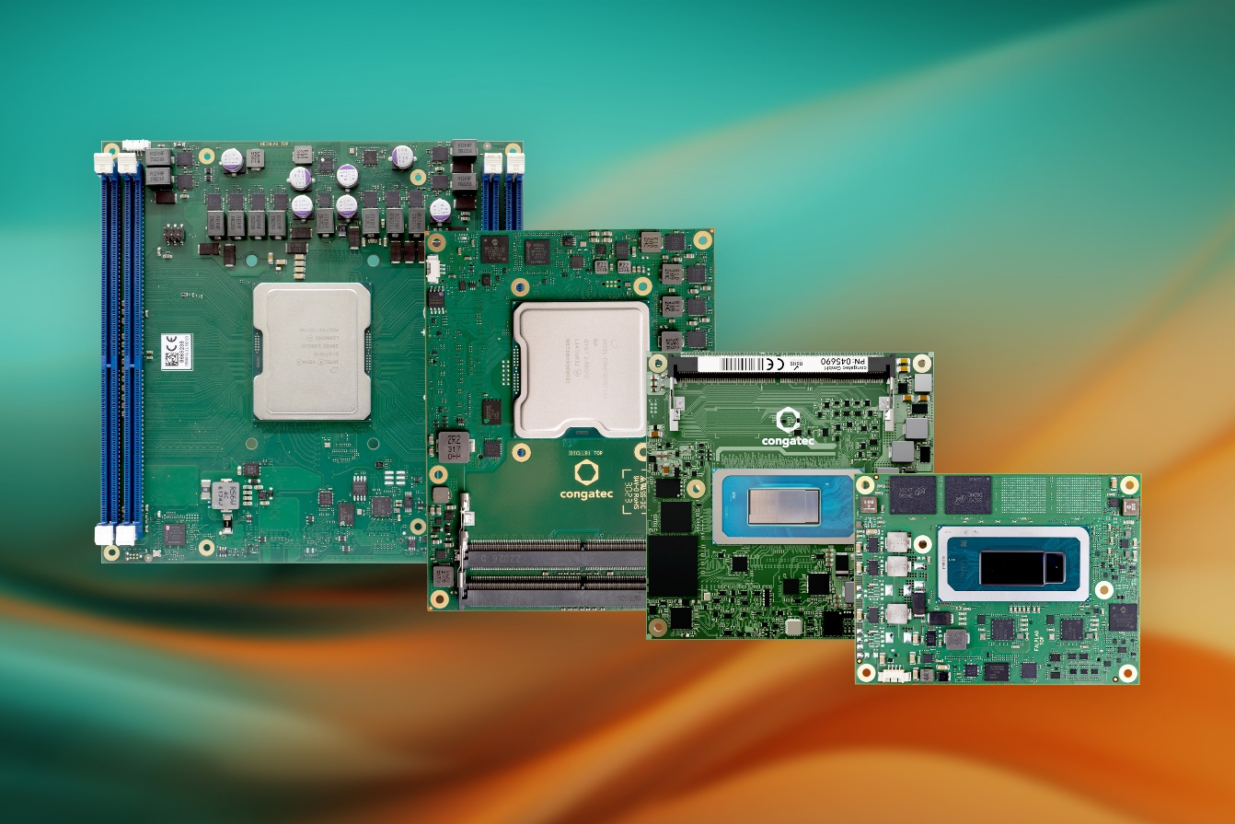
Shanghai, China, June 4, 2024 * * * congatec – a leading vendor of embedded and edge computing technology – will showcase its extensive range of Computer-on-Modules (COMs) as well as various customer system designs at embedded world China (Hall 3, Booth 441). Innovations include congatec’s novel aReady. strategy, new Intel Core Ultra processor-based modules with integrated AI, and further premieres based on innovative low-power as well as high-performance x86 processor technology. Presentations will focus on increased performance, energy efficiency, and integrated advanced IIoT and security functions previously unavailable in existing COM solutions. These aReady.COMs will significantly increase the application readiness of COMs, differentiating congatec’s offering from alternative procurement options by facilitating highly efficient and reliable development of modern, multifunctional, comprehensively connected embedded and IIoT devices.

“The IIoT presents OEMs with major challenges, which we, as a Computer-on-Module supplier, are now addressing with an extensively expanded range of functions of our COM-HPC, COM Express, SMARC, and Qseven-based modules. For example, module-integrated hypervisor technology and IIoT functions make it easier for solution providers to enrich their applications with increased functionalities without having to develop or integrate them themselves. We will be demonstrating how our new aReady. strategy delivers added value to OEM customers at embedded world China,” explains Becky Lin, Sales Director at congatec China.

Showcase highlight: High-performance COM-HPC ecosystem
The highlight of congatec’s showcase is the complete ecosystem of COM-HPC modules, including the new COM-HPC Mini form factor. The congatec COM-HPC Mini modules with 13th Gen Intel Core processors (codenamed Raptor Lake) represent a major benchmark for high-end embedded and edge computing at the client level. Comprising modules, powerful cooling solutions, and carrier boards, congatec’s COM-HPC ecosystem demonstrates its performance through modular edge computing and edge server designs with fanless cooling. Now, all congatec COM-HPC modules are also available as aReady.COMs.

High-performance Server-on-Module ecosystems
Featuring COM Express Type 7 as well as COM-HPC Server modules, congatec’s high-performance Server-on-Module ecosystems are optimized for the highest bandwidth and performance demands of powerful edge servers. These modules are designed to support a wide range of industrial needs, from workload consolidation servers for automation, robotics, and medical backend imaging, to robust outdoor servers for utilities and critical infrastructures. They also cater to the advanced requirements of autonomous vehicles and video infrastructures for safety and security. Another fundamental building block of the ecosystems is high-performance cooling, including rugged and passive cooling options that ensure reliable operation in harsh environments. Additionally, versatile carrier boards simplify the integration process, making it easier for developers to design and deploy these solutions in various applications.

AI upgrade for the edge
Additionally, visitors can see congatec’s latest range of AI acceleration modules, including a new COM Express Compact module based on Intel Core Ultra processors (codenamed Meteor Lake). Providing a unique mix of heterogeneous compute engines, these new modules are ideal to run demanding AI workloads at the edge.

A new performance benchmark for future-facing industrial edge computing and powerful virtualization is set by congatec’s credit-card-sized conga-SA8 SMARC modules. Based on Intel Atom x7000RE Series processors (codenamed Amston Lake) and Intel Core i3 processors, they deliver twice as many cores as the previous generation – while maintaining the same power consumption. Target applications are smart factory applications requiring high-performance real-time computing with powerful AI capabilities. Examples include inspection systems, stationary robotic arms, and autonomous mobile robots (AMRs).

* * *
About congatec
congatec is a rapidly growing technology company focusing on embedded and edge computing products and services. The high-performance computer modules are used in a wide range of applications and devices in industrial automation, medical technology, robotics, telecommunications and many other verticals. Backed by controlling shareholder DBAG Fund VIII, a German midmarket fund focusing on growing industrial businesses, congatec has the financing and M&A experience to take advantage of these expanding market opportunities. congatec is the global market leader in the Computer-on-Modules segment with an excellent customer base from start-ups to international blue chip companies. More information is available on our website at www.congatec.com or via LinkedIn, X (Twitter) and YouTube.

Reader enquiries:
congatec
Crysta Lee
Phone: +886 2 25978577
info@congatec.com
www.congatec.com

Press contact congatec:
congatec
Christof Wilde
Phone: +49-991-2700-2822
christof.wilde@congatec.com

Intel, the Intel logo, and other Intel marks are trademarks of Intel Corporation or its subsidiaries.

